**Praktik 1**

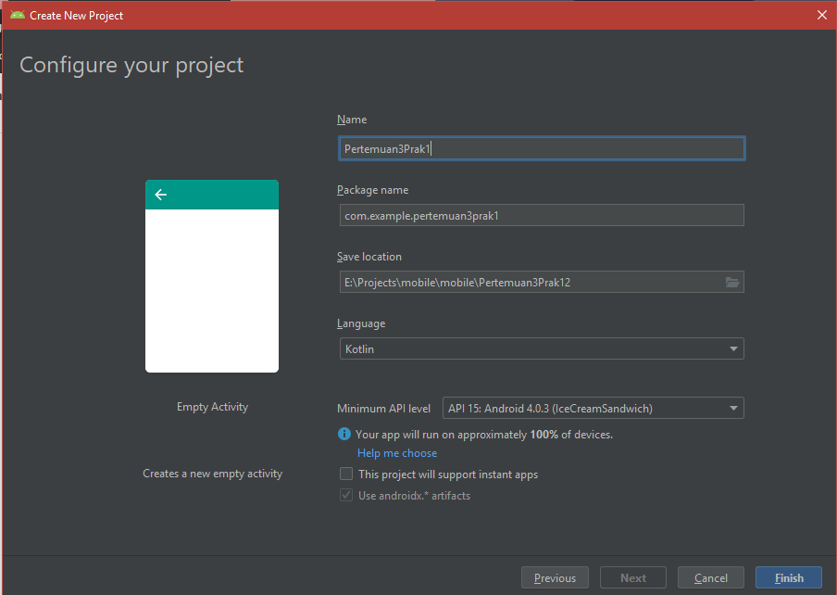

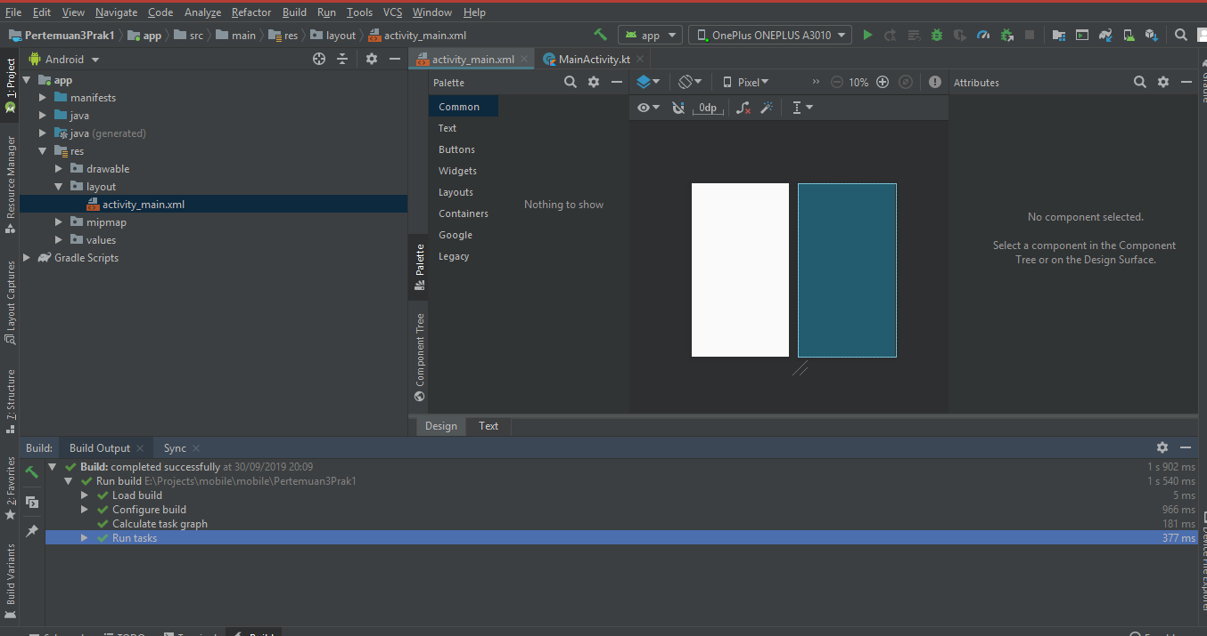

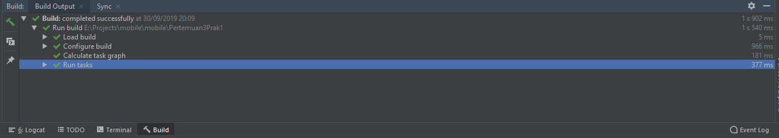

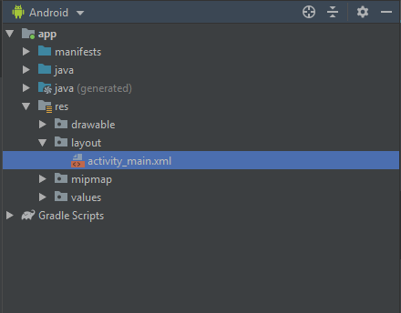 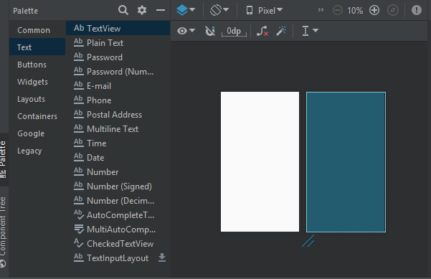

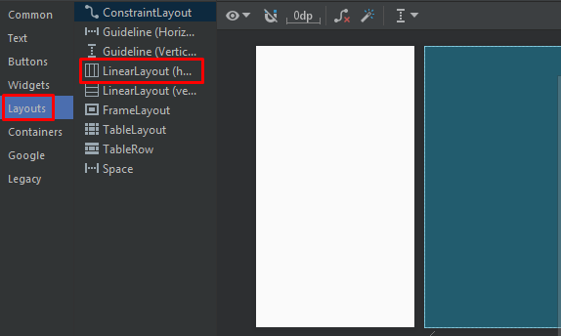

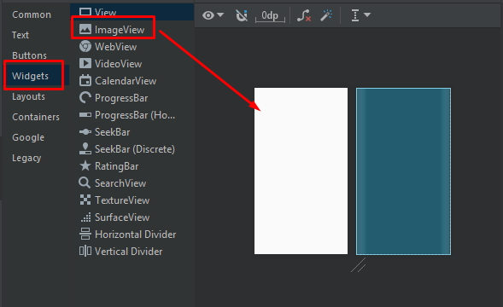

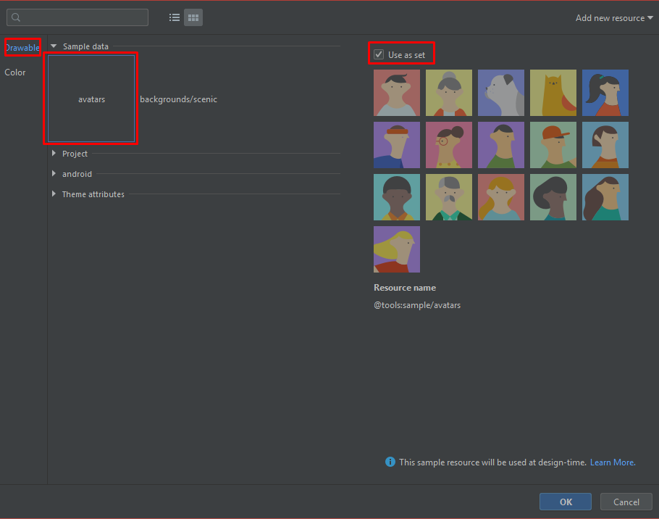

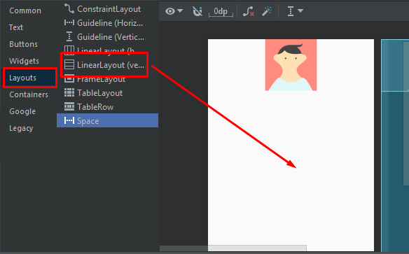 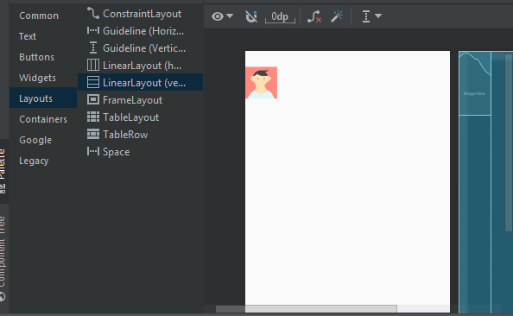

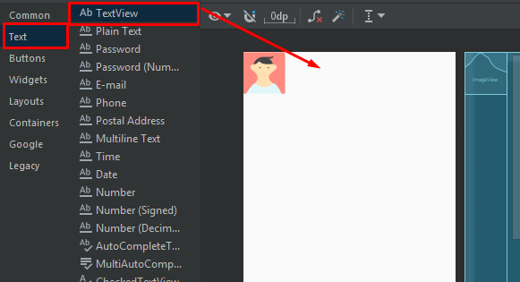

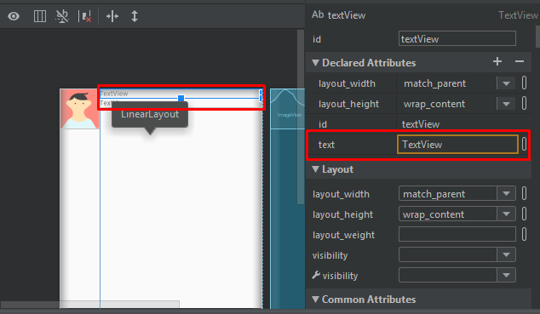

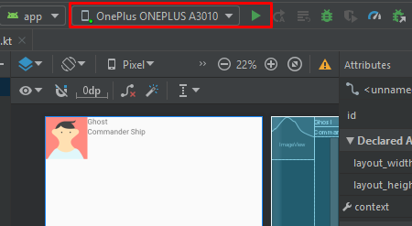

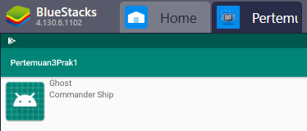

Kode program praktik 1

|  |
| --- |
| <?xml version="1.0" encoding="utf-8"?>  <androidx.constraintlayout.widget.ConstraintLayout xmlns:android="http://schemas.android.com/apk/res/android"  xmlns:app="http://schemas.android.com/apk/res-auto"  xmlns:tools="http://schemas.android.com/tools"  android:layout_width="match_parent"  android:layout_height="match_parent"  tools:context=".MainActivity">  <LinearLayout  android:layout_width="match_parent"  android:layout_height="match_parent"  android:orientation="horizontal"  tools:layout_editor_absoluteX="210dp"  tools:layout_editor_absoluteY="180dp">  <ImageView  android:id="@+id/imageView"  android:layout_width="161dp"  android:layout_height="82dp"  android:layout_weight="1"  app:srcCompat="@mipmap/ic_launcher"  tools:srcCompat="@tools:sample/avatars" />  <LinearLayout  android:layout_width="match_parent"  android:layout_height="match_parent"  android:layout_weight="1"  android:orientation="vertical">  <TextView  android:id="@+id/textView"  android:layout_width="match_parent"  android:layout_height="wrap_content"  android:text="Ghost" />  <TextView  android:id="@+id/textView2"  android:layout_width="match_parent"  android:layout_height="wrap_content"  android:text="Commander Ship" />  </LinearLayout>  </LinearLayout>  </androidx.constraintlayout.widget.ConstraintLayout> |

**Praktik 2**

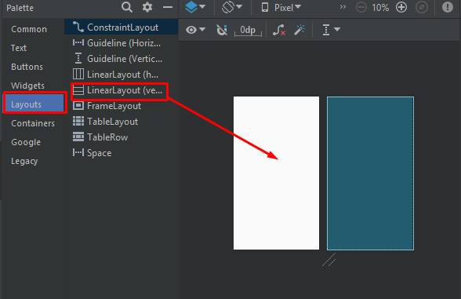

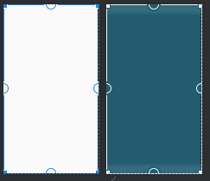 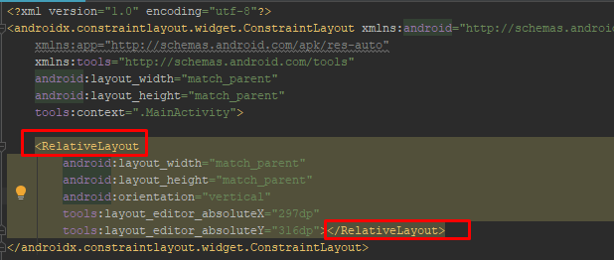

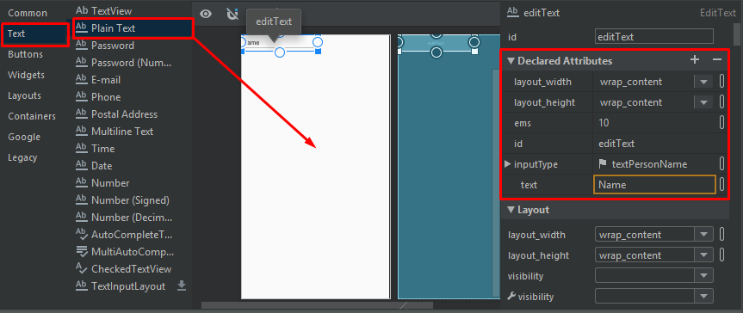

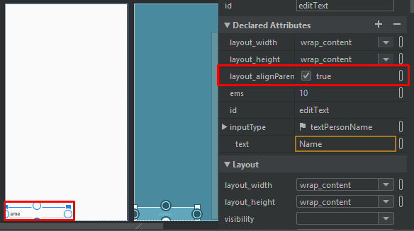

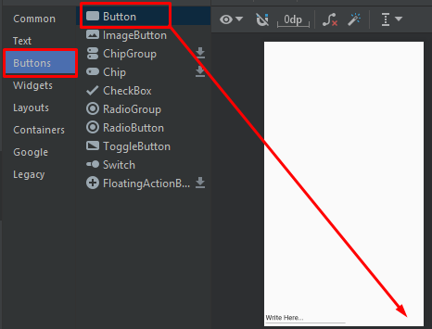

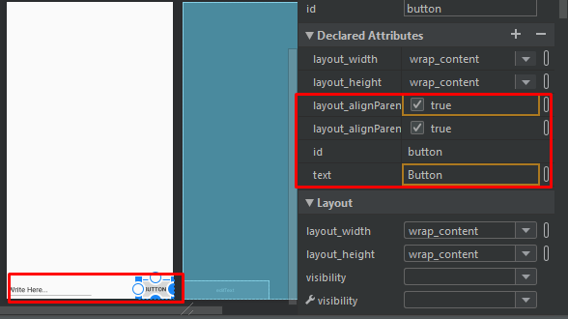

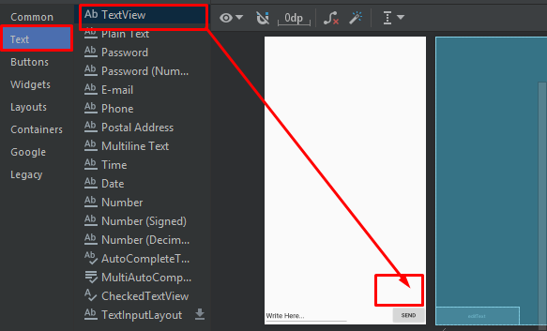

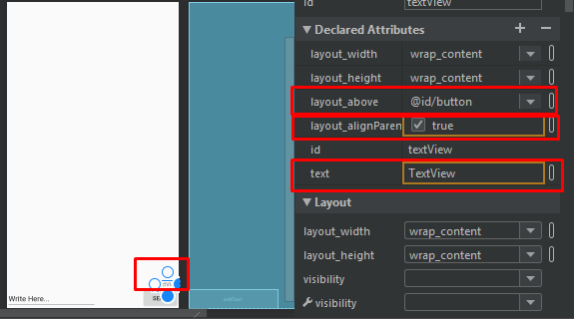

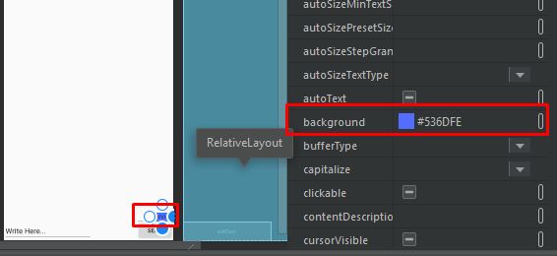

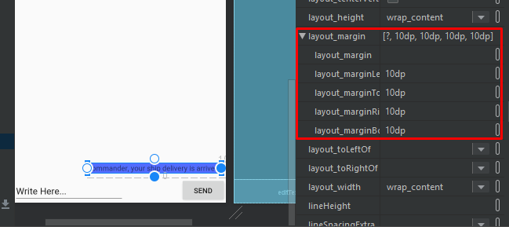

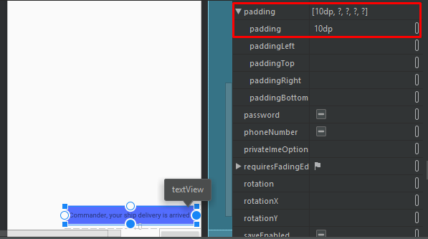

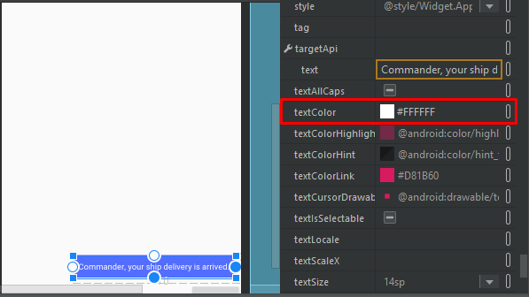

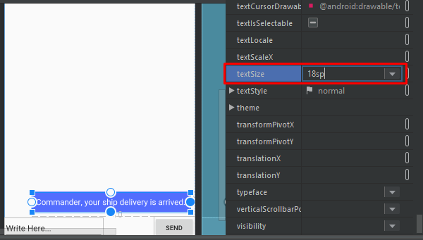

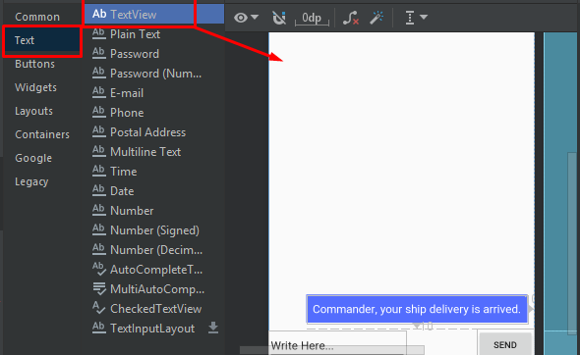

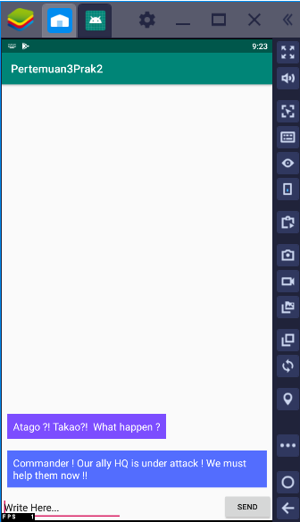

Kode Praktik 3

|  |
| --- |
| <?xml version="1.0" encoding="utf-8"?>  <androidx.constraintlayout.widget.ConstraintLayout xmlns:android="http://schemas.android.com/apk/res/android"  xmlns:app="http://schemas.android.com/apk/res-auto"  xmlns:tools="http://schemas.android.com/tools"  android:layout_width="match_parent"  android:layout_height="match_parent"  tools:context=".MainActivity">  <RelativeLayout  android:layout_width="match_parent"  android:layout_height="match_parent"  android:orientation="vertical"  tools:layout_editor_absoluteX="43dp"  tools:layout_editor_absoluteY="84dp">  <EditText  android:id="@+id/editText"  android:layout_width="wrap_content"  android:layout_height="wrap_content"  android:layout_alignParentBottom="true"  android:ems="10"  android:inputType="textPersonName"  android:text="Write Here..." />  <Button  android:id="@+id/button"  android:layout_width="wrap_content"  android:layout_height="wrap_content"  android:layout_alignParentRight="true"  android:layout_alignParentBottom="true"  android:text="Send" />  <TextView  android:id="@+id/textView"  android:layout_width="wrap_content"  android:layout_height="wrap_content"  android:layout_above="@id/button"  android:layout_alignParentRight="true"  android:layout_marginStart="10dp"  android:layout_marginLeft="10dp"  android:layout_marginTop="10dp"  android:layout_marginEnd="10dp"  android:layout_marginRight="10dp"  android:layout_marginBottom="10dp"  android:background="#536DFE"  android:padding="10dp"  android:text="Commander ! Our ally HQ is under attack ! We must help them now !!"  android:textColor="#FFFFFF"  android:textSize="18sp" />  <TextView  android:id="@+id/textView4"  android:layout_width="wrap_content"  android:layout_height="wrap_content"  android:layout_above="@id/textView"  android:layout_marginStart="10dp"  android:layout_marginLeft="10dp"  android:layout_marginTop="10dp"  android:layout_marginEnd="10dp"  android:layout_marginRight="10dp"  android:layout_marginBottom="10dp"  android:background="#7C4DFF"  android:padding="10dp"  android:text="Atago ?! Takao?! What happen ?"  android:textColor="#FFFFFF"  android:textSize="18sp" />  </RelativeLayout>  </androidx.constraintlayout.widget.ConstraintLayout> |